Command prompt or cmd is a default application of windows that are used to interact with any windows objects in the windows os. ... **PowerShell is a more advanced version of cmd**. It is not only an interface but also a scripting language that is used to carry out administrative tasks more easily.

CMD is the command line for Microsoft Windows operating system, with command-based features. Powershell is a task-based command-line interface, specifically designed for system admins and is based on the . Net Framework. Bash is a command-line and scripting language for most Unix/Linux-based operating systems

The shell is **the Linux command line interpreter**. It provides an interface between the user and the kernel and executes programs called commands. ... The shell can also execute other programs such as applications, scripts, and user programs (e.g., written in c or the shell programming language).

**Different Types of Shells in Linux**

* The Bourne Shell (sh) Developed at AT&T Bell Labs by Steve Bourne, the Bourne shell is regarded as the first UNIX shell ever. ...
* The GNU Bourne-Again Shell (bash) ...
* The C Shell (csh) ...
* The Korn Shell (ksh) ...
* The Z Shell (zsh)

What are the 4 main types of shells?

**Shell Types**

* Bourne shell (sh)
* Korn shell (ksh)
* Bourne Again shell (bash)
* POSIX shell (sh)

<https://www.journaldev.com/39194/different-types-of-shells-in-linux>

SHELL is a program which provides the **interface between the user and an operating system**. When the user logs in OS starts a shell for user. Using kernel only user can access utilities provided by operating system

<https://www.geeksforgeeks.org/different-shells-in-linux/>

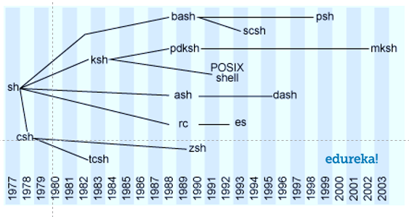

Bash (**Bourne Again Shell**) is the free and enhanced version of the Bourne shell distributed with Linux and GNU operating systems. ... Bash is intended to conform to the shell standard specified as part of IEEE POSIX. A command language script written for the Bourne shell should also run in the bash shell.

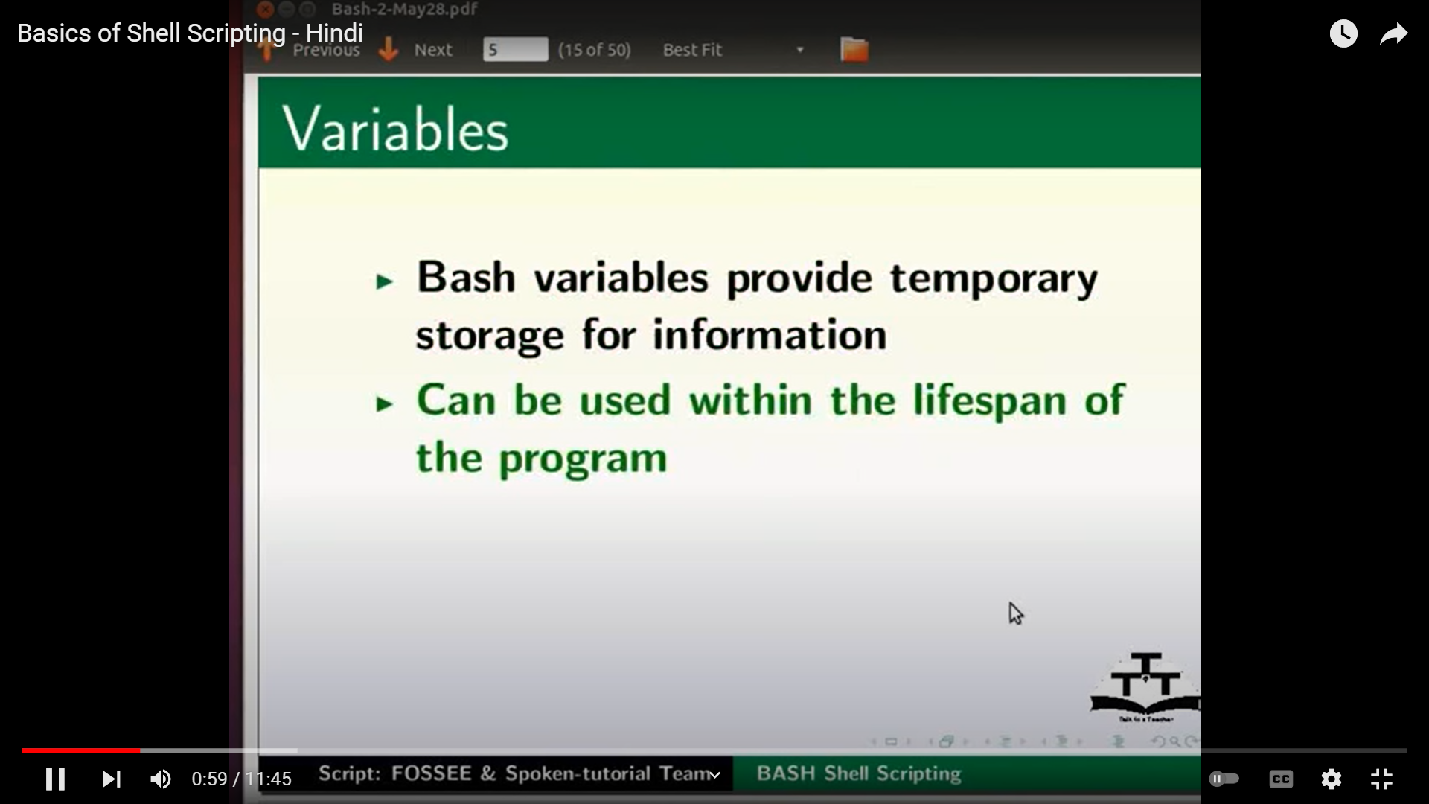

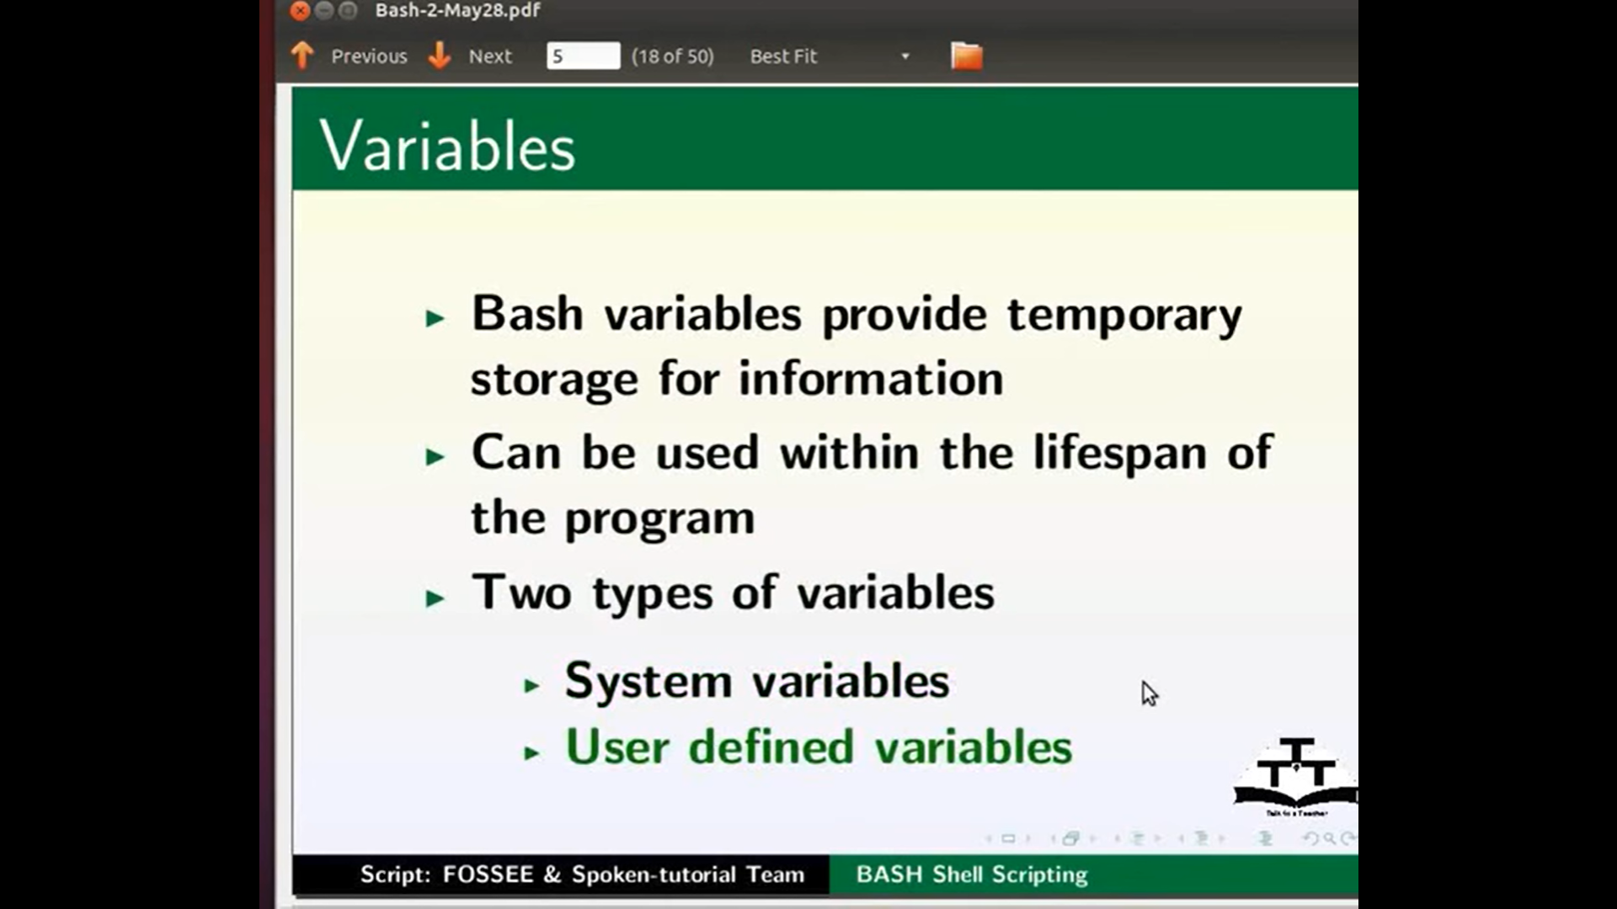

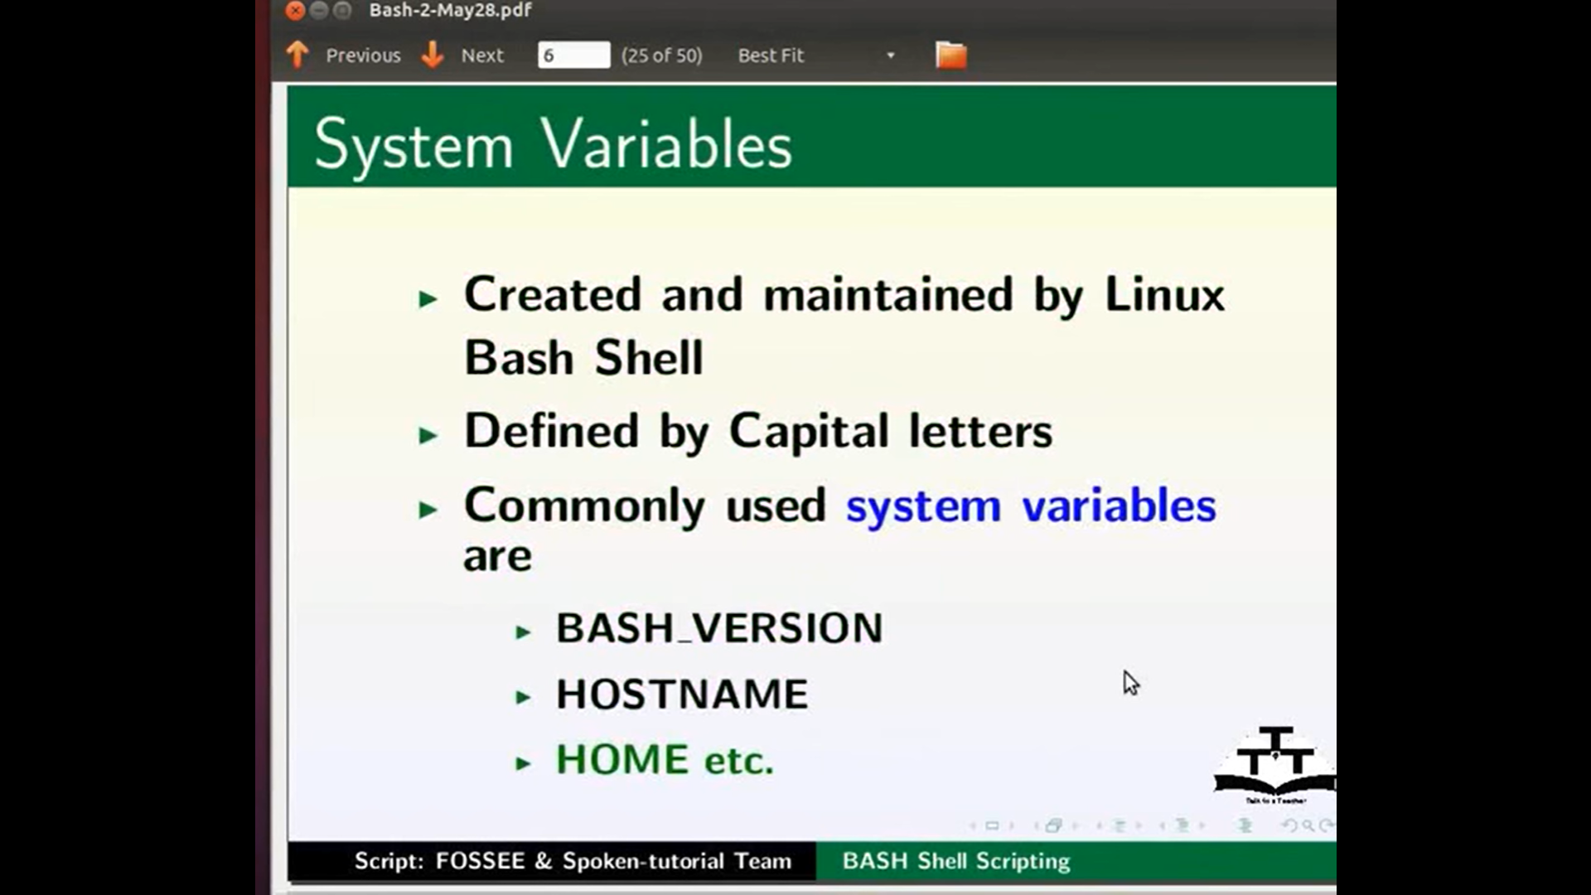

Set > gives you all system variables

Printenv > env variables

Echo “$HOME”

Echo “$HOSTNAME”

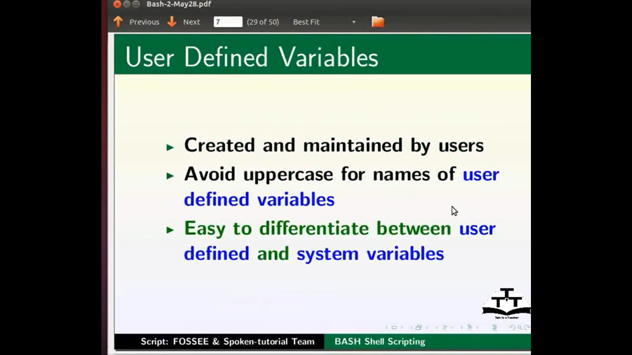

User=”name”

Unset

Echo “$user”

Unset user

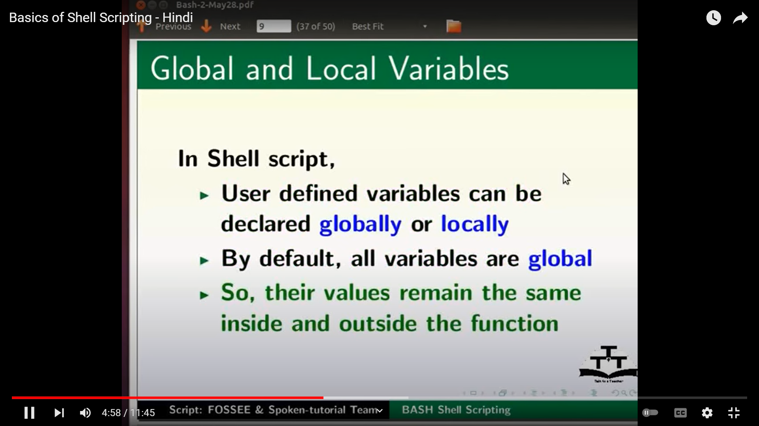

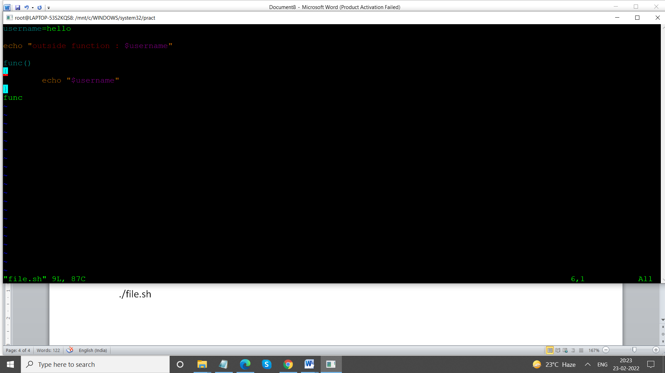

Chmod +x file.sh

./file.sh

